**User Manual**

**Project:**

THE VOICES

V1.0

Table of Content

Contents

1.0 Waiting Room 3

1.1 Chat bot ………………………………………………………………………………4

2.0. Maze Game…………………………………………………………………………………………………………..5

2.1 Maze 6

3.0 Ending of Story 7

4.0Bonus Game…………………………………………………………………………………………………………………………8

5.0 Ending of Session……………………………………………………………………………………………9

6.0 Signage Page…………………………………………………………………………………10

# 1.0. Waiting Room

Below is the view of the waiting page after registering.

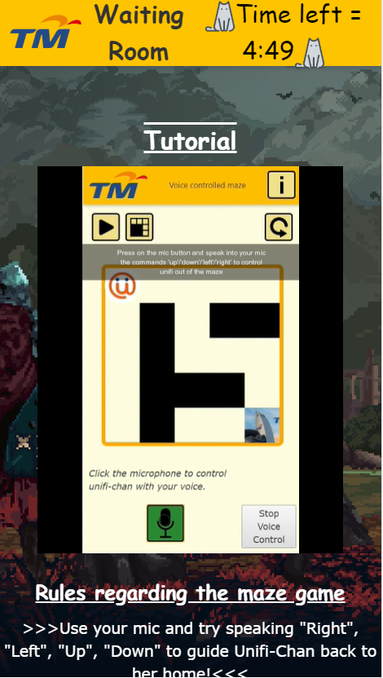

The page includes a timer that is displayed on the top right and when the timer finishes , users will be redirected to the maze game. The page also has a chat function to let users chat with other user , a video guide on how to play the maze game and also a redirection to the chat bot where user can play with our chat bot while waiting.

## 1.1 Chat Bot

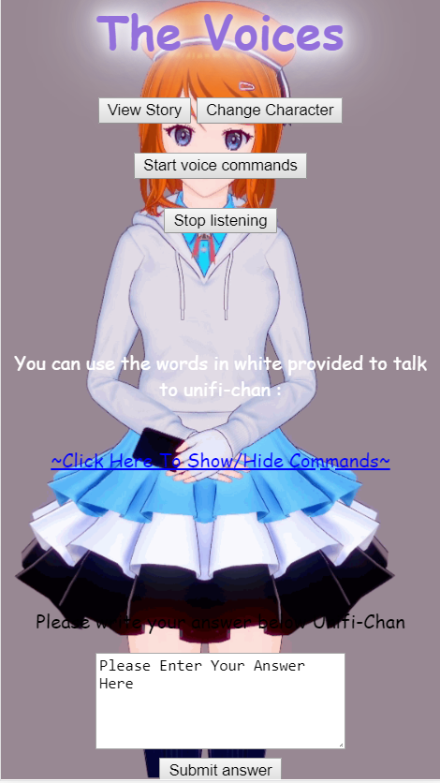

After clicking on the chat bot button in the waiting room , users will be redirected to this page and can view the storyboard , change to another chat bot character , answer questions by the chat bot and also talk to the chat bot using ur mic and the commands provided.

**2.0 Maze game**

# 

# After the timer in the waiting room has finished , user will be redirected to this page to play with our maze game. You will need to speak in the mic the commands : up / down / left / right in order to control unifi out of the maze. Your time will be recorded once you press on the start button and will be displayed once you cleared the maze. The token given is : Easy difficulty no.1=5 token , no.2=4 token , no.3=3 token , participating =1 token. Hard difficulty no.1=7 token , no.2=6 token , no.3=5 token , participating =2 token.

**2.1 Maze**

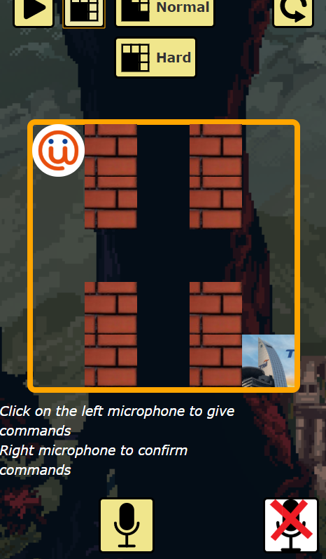

Once you press on start , this is the maze game you will be playing. You have 40 seconds to clear this maze otherwise you will have to start over in a newly generated maze. Each play session has a 5 minute countdown. Once 5 minute is up , all user will be redirected to the ending page. If you finished the maze already , you can choose to try the maze again for better time in the scoreboard or view the ending of the story. User can also choose to play either the easy or hard difficulty of the maze.

**3.0 Ending of story**

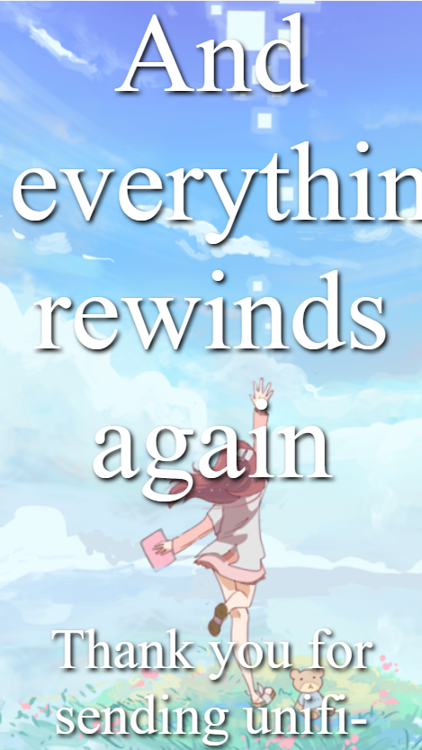

After user have finish playing the maze game or the 5 minute play session time is up , they will be redirected to view this ending page. There is a button below which will lead to a bonus game. The bonus game is optional but it gives extra token for it.

**4.0 Bonus Game**

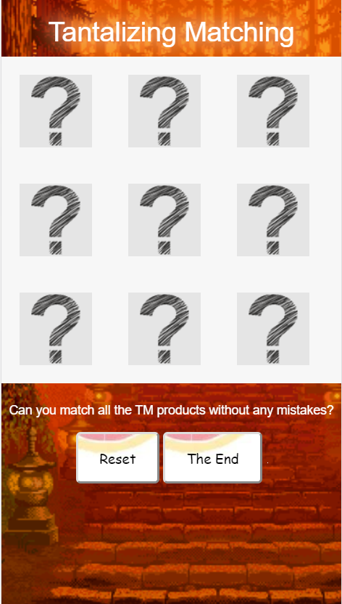

The bonus game is a match 2 pair of same card memory game. Users are awarded 1 token upon completion.

**5.0 Ending of Session**

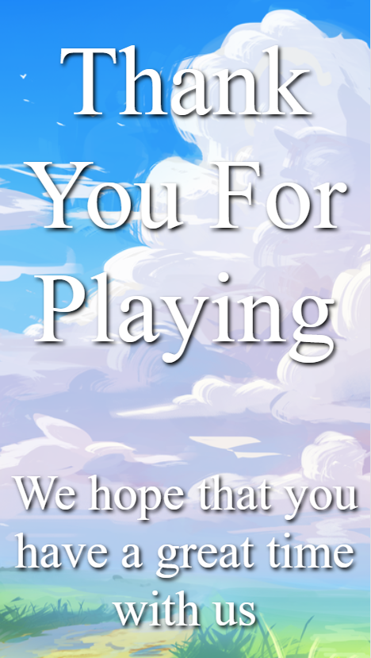

Once user have finish playing the bonus game , they will be redirected to the thank you page.

**6.0 Signage Page**

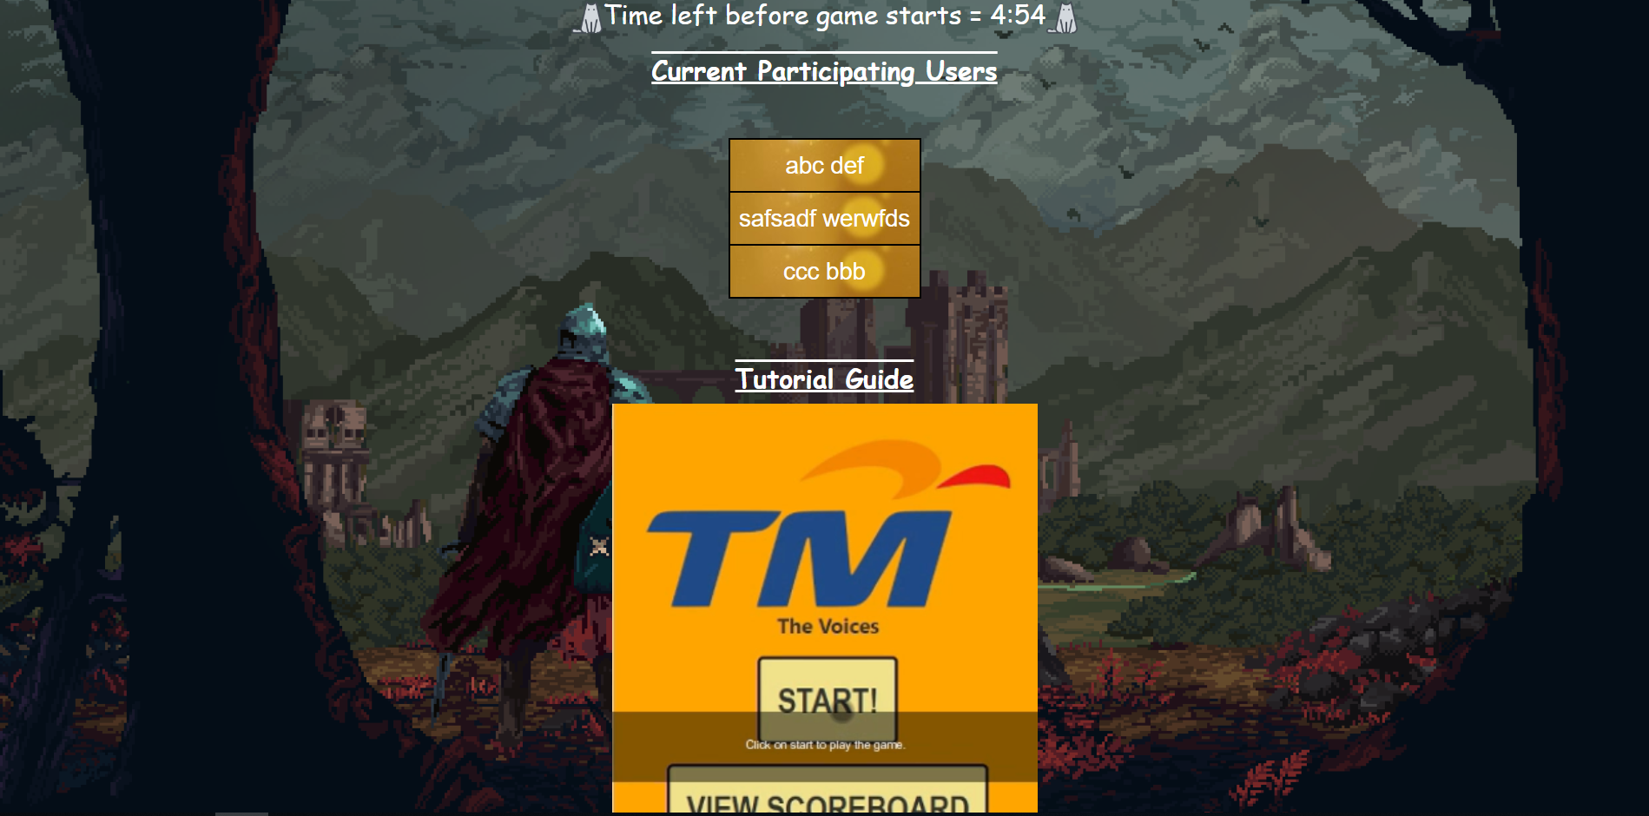

This is the page to be displayed at the signage . Displays current participating users , video guide and also timer before switching to scoreboard.